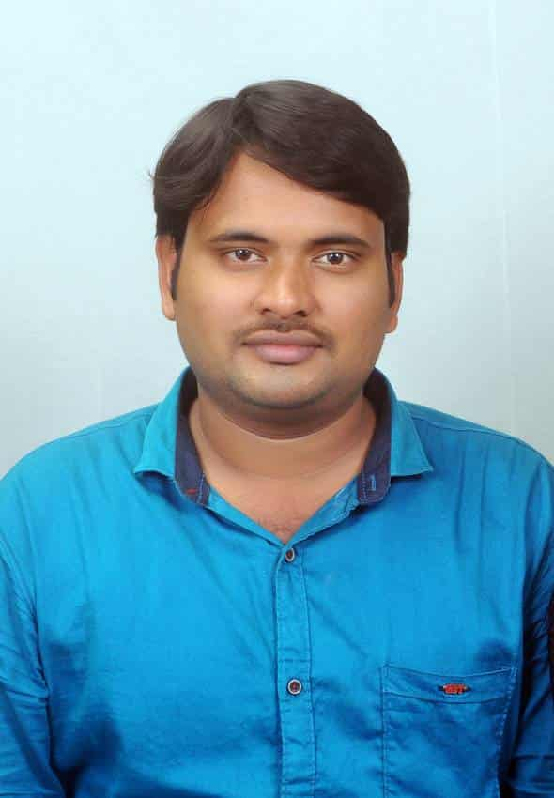

MATHA RAJESH M.A., B.Ed., AP-SET.

Assistant Professor of English

# Email Id: www.matha.rajesh4christ@gmail.com

**Phone no: 7013384346,9666493908.**

**CAREER OBJECTIVE:**

To pursue a career with an organization which will help me to explore and achieve expertise through opportunities and learning, which enhances my skills along with organizational success.

**ACADEMIC QUALIFICATIONS:**

|  |  |  |  |
| --- | --- | --- | --- |
| **Course** | **Year of passing** | **Name of the**  **institution** | CGPA**/ Percentage** |
| M.A  (English lit.) | 2013 | MSN PG Center  Andhra University  Kakinada. | 5.85 |
| B.Ed.  (Social Studies & English) | 2011 | Regency College Of Education, Yanam.  Pondicherry university | 65% |
| B.A  (H.E.P) | 2010 | Sri.P.R.Govt Degree  College (A) KKD | 57.5% |
| Intermediate | 2007 | Sri.P.A Jr.College  KKD | 53% |
| SSC | 2005 | Z.P.High School  Gurajanapalli. | 53% |

Qualified AP-SET in APRIL 2024 Cycle with 45%

**PROFESSIONAL EXPERIENCE:**

1. **Assistant Professor of English**

Ideal College Of Arts And Sciences, Kakinada **(2021-** till date)

1. **Lecturer in English**

K.V Jr.College, Kakinada ( 020-2021)

1. **English Teacher**

K.T.C High School, Bramhananda Puram, Kakinada. (2017-2020)

1. **English Teacher**

Narayana e-techno School, Yanam. (2013- 2017)

**TECHNICAL SKILLS**

* MS Word
* MS Power Point

**SOFT SKILLS**

* Good Communication Skills
* Positive Attitude
* Hard Working

## PERSONAL PROFILE:

Name : MATHA RAJESH

Father Name : M. SUDARSANA RAO

Mother Name : M. MARY KUMARI

Date of Birth : 08/07/1990

Nationality : Indian

Marital Status : Married

Gender : Male

Languages Known : English, Telugu

Hobbies : Reading Books, Listening to Music and Playing Cricket.

# DECLARATION:

I hereby declare that the above-mentioned information is correct and accurate to the best of my knowledge and I bear the responsibility for the correctness of the above given particulars.

**M.RAJESH MA. B.Ed., AP-SETs**