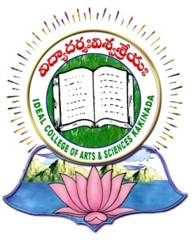 | IDEAL COLLEGE OF ARTS AND SCIENCES (A)
 | (A.P. Govt., Aided., Autonomous & NAAC B++)
 | VIDYUT NAGAR
KAKINADA
East Godavari Dist
Andhra Pradesh

Department of MBA PROGRAMME

PROFILE

- Name : P.S.PADMAVATI
- Designation and Place of work : ASSISTANT PROFESSOR
Ideal College of Arts and Sciences
Kakinada-533003.
A.P., INDIA.
- Date of Birth : 10/04/1974
- Nationality : Indian
- Mobile no : 9989842888
- E-mail : s.sudha34@gmail.com
- Address for Correspondence :
Assistant Professor
Ideal College of Arts & Sciences,
Kakinada – 533 003, A.P., India.

- Details of Educational Qualifications:
Sl. No. | Course | University | Year | Specialization
1. | MBA | ANDHRA UNIVERSITY | 2008 | FINANCE&HUMAN RESOURCE MANAGEMET
2 | M COM | ANDHRA UNVIERSITY | 1996 | ACCOUNTANCY
3 | APSET | OSMANIA UNIVERSITY | 2012 | MANAGEMENT
4 | UGCNET | UGC | 2012 | MANAGEMENT
5 | Ph D | JNTUK | PERSUING | HRM

- Experience:

Sl. No | Designation | College | Date of Joining | Experience
1 | ASSISTANT PROFESSOR | RIMS, KAKINADA | 01/07/2008 | 1 YEAR
2. | ASSISTANT PROFESSOR | IDEAL COLLEGE OF ARTS AND SCIENCE KAKINADA | 07/08/2009 | 8 YEARS

- Regional/ State/National level Conferences/Workshops/Seminars

  - Attended NATIONAL WORKSHOP ON RESEARCH METHODOLOGY AND REPORT WRITING – COMMERCE, MANAGEMENT AND SOCIAL SCIENCES” on 29th – 30th January 2016, organized by Department of Management Studies, Adikavi Nannaya University, Rajahmundry.
  - Attended and presented paper at UGC National Seminar on” INSTITUTIONAL QUALITY MAINTANANCE AND IMPROVEMENT “, conducted on 21st and 22nd January 2017.
  - Participated in two day workshop on “stock broking and Mutual Funds” on 7th and 8th February 2013

- Training Programs/ Courses attended:
Attended one month course conducted by JNTUK Kakinada as part of PhD programme.
Published research paper in IJAR an article titled “competency mapping a key to success”.

