DEPARTMENT OF CHEMISTRY
PROFILE
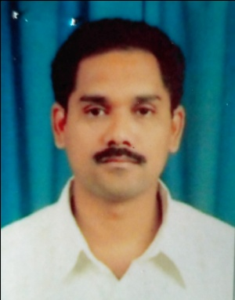
1. NAME: BORRA.SRINIVAS
2. DESIGNATION AND: LECTURER
PLACE OF WORK : IDEAL COLLEGE OF ARTS AND SCIENCES (A)
KAKINADA-533003, E.G.Dt.
AP., INDIA.
3. DATE OF BIRTH: 30-08-1973
4. NATIONALITY: INDIAN
5. MOBILE NUMBER: 9849202081
6. E-MAIL: borrasrinivas60@gmail.com
7. ADDRESS FOR COMUNICATION: BORRA.SRINIVAS
LECTURER IN CHEMISTRY
IDEAL COLLEGE OF ARTS AND SCIENCES (A)
KAKINADA-533003
AP., INDIA.
8. DETAILS OF EDUCATIONAL QUALIFICATIONS:

S.NO | COURSE | UNIVERSITY | YEAR | SPECILIZATION
1 | M.SC | ANDHRA UNIVERSITY | 1994-96 | INORGANIC CHEMISTRY
2 | M.PHIL | ACHARYA NAGARJUNA UNIVERSITY | 2007 | CHEMISTRY

9.EXPERIENCE:

S.NO | DESIGNATION | NAME OF THE COLLEGE | DATE OF JOINING | EXPERIENCE
1 | LECTURER | Bh.S.R. & V.L.M. DEGREE COLLEGE | 05-08-1996 | 4 YEARS
2 | LECTURER | IDEAL P.G. COLLEGE. | 16-12-2000 | 17 YEARS

10. REGIONAL /STATE/NATIONAL LEVEL CONFERENCES/ WORK SHOPS/ SEMINARS:
A) MODERN ASPECTS OF SPECTROSCOPIC TECHNIQUES, 27-02-2016
B) MODERN ASPECTS OF ORGANIC SPECTROSCOPIC TECHNIQUES, 10-02-2017

11. ADMINISTRATIVE EXPERIENCE: ASSISTANT COORDINATOR IN IGNOU
12. TRAINING PROGRAMS /COURSES ATTENDED: NIL

