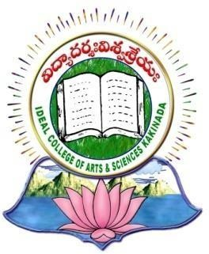

|  |
| --- |
| **IDEAL COLLEGE OF ARTS AND SCIENCES (A)** |
| ***(Autonomous & NAAC B)*** |
| **Dr. P.V.N. RAJU VIDYAPRANGANAM** |
| **Samalkot Road, KAKINADA** |

Department of English

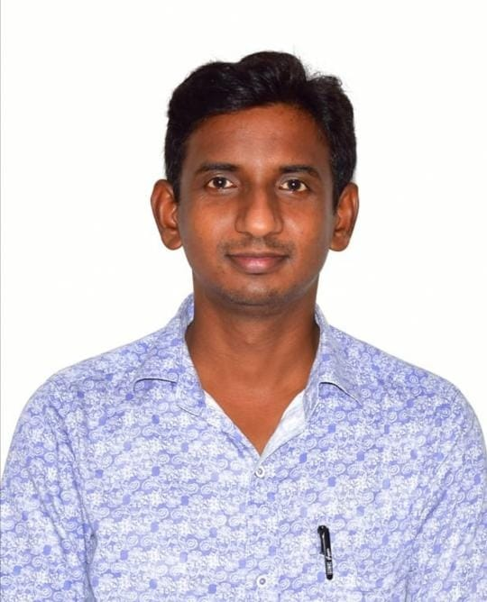

**PROFILE**

1. **Name : NANI BABU UCHULA**
2. **Designation and Place of work: Lecturer in English**

**Ideal College of Arts & Sciences (A) Kakinada-533003**

**A.P., INDIA.**

1. **Date of Birth :** 18.06.1983
2. **Nationality :** Indian

**5. Mobile no** 9848807795

1. **E-mail :** [**nanieng5@gmail.com**](mailto:nanieng5@gmail.com)
2. **Address for Correspondence** : **U. Nani Babu**

Lecturer in English

Ideal College of Arts & Sciences, Kakinada – 533 003, A.P., India.

1. **Details of Educational Qualifications:**

|  |  |  |  |  |
| --- | --- | --- | --- | --- |
| **S. No** | **Course** | **University** | **Year** | **Specialization** |
| 1. | M.A. English | Sri Y.N.College, Narsapuram | 2006 | Language & Litarature |
| 2. | B.Ed. | Bathny College of Education, Ravulapalem | 2008 | Special English |

1. **Experience:**

|  |  |  |  |
| --- | --- | --- | --- |
| **Sl. No** | **Designation** | **College** | **Date of Joining Experience** |
| 1. | LECTURER IN  English | IDEAL COLLEGE OF ARTS &  SCIENCES, KAKINADA | 01.10.2021 |
| 2. | LECTURER IN  English | Sri Chaitanya Junior College, Razole | 2012 to  2021 |

# Online Certificate Course:

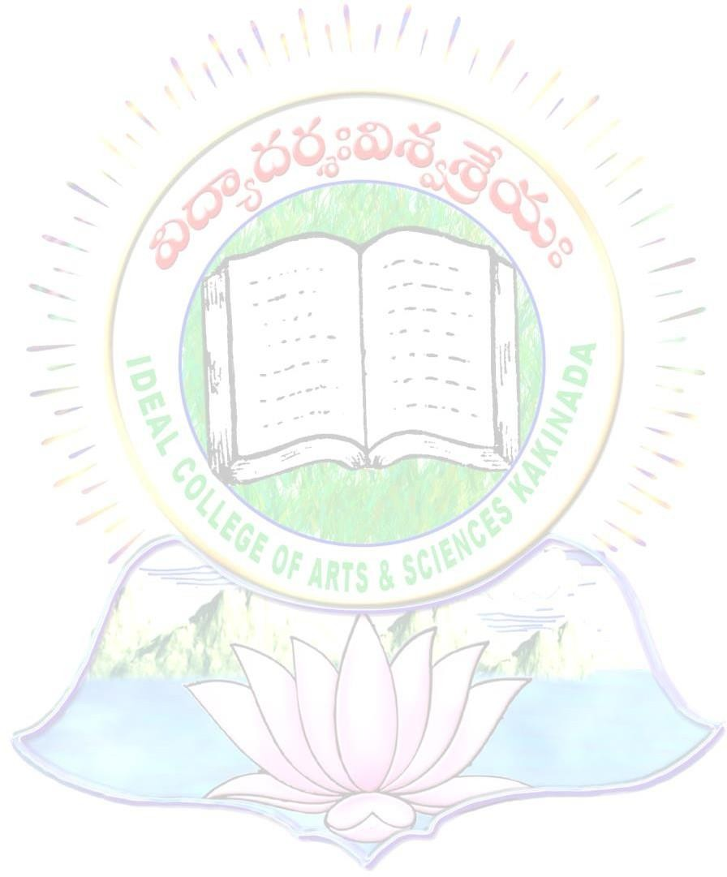

* + Successfully completing the online certificate course **“Communication Skills in New Era”** for 4th October 2024. Nagarjuna University, Guntur.

1. **Faculty Development Programme:**

* I have participated in the National Webinar on “**Blooms Taxonomy of OBE**” conducted by The Department of English, Hindu College, Guntur on 28.03.2022
* I participated One Week Online Faculty Development Programme on “**Major Literary Theories”** conducted by Department of English, Krishna University held from 26th July 2022 to 2nd August 2022.

# State Level Seminar: (2)

* Two day state level seminar **on “Romantic Poetry in English & Bhavakavitvam in Telugu”** at Ideal College of Arts and Sciences (A), Kakinada, East Godavari District, Andhra Pradesh and Participated**.**

# State Level Work Shops: (2)

* One Day State level Workshop on “**Communication skills with Special Focus on Attitude”** at Ideal College of Arts and Sciences (A), Kakinada, East Godavari District, Andhra Pradesh and Participated**.**
* One Day State level Workshop on “**Tips to Speak English Easily”** at Ideal College of Arts and Sciences (A), Kakinada, East Godavari District, Andhra Pradesh and Participated

# IQAC seminars: (2)

* One Day Faculty Development Programme Organized by Department of Home Science on **“Massive Open Online Courses (MOOCs) Designing and Creation”** at A. S. D. Govt. Degree College for Women (A), Kakinada, East Godavari District, Andhra Pradesh and Participated.
* One Day Faculty Development Programme Organized by Department of English on **“Teaching Learning and Evaluation in Higher Education”** at Y.N.College, Narsapur, Andhra Pradesh and Participated.