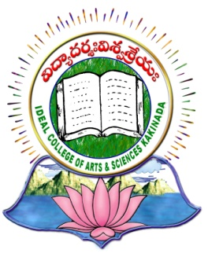 | IDEAL COLLEGE OF ARTS AND SCIENCES (A)
 | (A.P. Govt., Aided., Autonomous & NAAC B++)
 | Dr. P.V.N. RAJU VIDYAPRANGANAM
Samalkot Road, KAKINADA
East Godavari Dist
Andhra Pradesh

Department of Chemistry

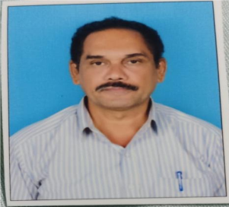

Profile

- Name : BORRA SRINIVAS
- Designation and Place of work : Lecturer in Chemistry
Ideal College of Arts & Sciences (A)
Kakinada-533003
A.P., INDIA.
- Date of Birth : 30-08-1973
- Nationality : Indian
- Mobile no : 9849202081
- E-mail : borrasrinivas60@gmail.com

- Address for Correspondence : BORRA SRINIVAS
Lecturer in Chemistry
Ideal College of Arts & Sciences,
Kakinada – 533 003, A.P., India.

- Details of Educational Qualifications:
Sl. No | Course | University | Year | Specialization
1.  2. | M.Sc  M.phil | Andhra University  Acharya Nagarjuna University | 1996  2008 | Inorganic Chemistry  Water Analysis

- Experience:

Sl. No | Designation | College | Date of Joining | Experience
1 | Lecturer | Ideal college of Arts & Sciences, Kakinada | 17-12-2000 | 23 years

- Administrative Experience:
  - IGNOU Assistant Coordinator

- Regional/ State/National and International level Conferences/Workshops/Seminars
  - Attended “One Day State Level Seminar on Recent Trends in Material Science” held at Ideal College of Arts & Sciences, Kakinada.

- Research Work:

