IDEAL COLLEGE OF ARTS AND SCIENCES (A)
(A.P. Govt., Aided., Autonomous & NAAC B++)
Dr. P.V.N. RAJU VIDYAPRANGANAM
Samalkot Road, KAKINADA
East Godavari Dist
Andhra Pradesh

P.G. Department of Computer Science
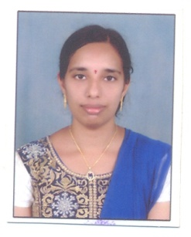

PROFILE

- Name : KANDA VENKATA VIJAYA LAKSHMI MADHURI
- Designation and Place of work : Assistant Professor ,
Ideal College of Arts & Sciences (A),
Vidyut nagar,Kakinada-533003
A.P., INDIA.
- Date of Birth : 25-08-1993
- Nationality : Indian
- Mobile no : 9705511610
- E-mail : kandamadhuri@gmail.com
- Address for Correspondence : K.V.V.L. Madhuri,
Assistant Professor,
P.G. Department of Computer Science,
Ideal College of Arts & Sciences,
Vidyutnagar, Kakinada – 533 003,
A.P., India.

- Details of Educational Qualifications:
Sl. No. | Course | University | Year | Specialization
1 | M.Sc. | Andhra University | 2015 | Computer Science
2 | B.Sc. | Andhra University | 2013 | M.E.Cs.
3 | Inter | Board of Intermediate Education, A.P. | 2010 | MPC
4 | SSC | Board Of Secondary Education | 2008

- Experience:
Sl. No | Designation | College | Date of Joining | Experience
1 | Assistant Professor | IDEAL P.G. COLLEGE, KAKINADA | 19-06-2017 TO till-date | 4 months

- Regional/ State/National level Conferences/Workshops/Seminars: - NIL
- Administrative Experience:- NIL
- Training Programs/ Courses attended:- NIL

(K.V.V.L.MADHURI)

