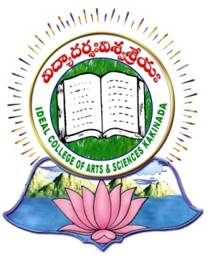 | IDEAL COLLEGE OF ARTS AND SCIENCES (A)
 | (A.P. Govt., Aided., Autonomous & NAAC B++)
 | Dr. P.V.N. RAJU VIDYAPRANGANAM
Samalkot Road, KAKINADA
East Godavari District
Andhra Pradesh

Department of Computer Science
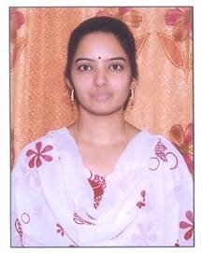

PROFILE

- Name : P.Radhika Krupalini
- Designation and Place of work : Associate Professor ,
Ideal College of Arts & Sciences (A),
Vidyut nagar,Kakinada-533003
A.P., INDIA.
- Date of Birth : 07/05/1978
- Nationality : Indian
- Mobile no : 9246691771
- E-mail : r.krupalini@gmail.com
- Address for Correspondence : P.Radhika Krupalini,
Associate Professor,
Ideal College of Arts & Sciences,
Vidyutnagar, Kakinada – 533 003,
A.P., India.

- Details of Educational Qualifications:
Sl. No. | Course | University | Year | Specialization
1 | M.Tech | JNTUK,Kakinada | 2010 | CSE
2 | MCA | Andhra University | 2002 | Computer Applications

- Experience:
Sl. No | Designation | College | Date of Joining | Experience
1 | Associate Professor | IDEAL P.G. COLLEGE, KAKINADA | 20-02-2010 TO till-date | 7 years 8 months
2 | Lecturer | IDEAL P.G. COLLEGE, KAKINADA | 23-06-2005 TO 19-02-2010 | 4 years 8 months

- Regional/ State/National level Conferences/Workshops/Seminars
Workshops attended:
- A one week National level workshop on “Data Mining Applications through Clememtine”, TEQUIP, JNTUK,UCE, Kakinada, 18-03-2009 to 19-03-2009.
- A one week National level workshop on “Application of Image Processing & Security”, TEQUIP, JNTUK, UCE, Kakinada,
23-03-2009 to 24-03-2009.
- A one week National level workshop on “Mobile & High Performance Computing”, TEQUIP,JNTUK, UCE, Kakinada, 25-03-2009 to 26-03-2009.
- A one week National level workshop on “Women Scientist Sensitization”, Centre for Empowerment of Women & Grievances, JNTUK, UCE, Kakinada, 09-02-2010 to 10-02-2010.
- A one week National level workshop on “Research Challenges and Issues in Big Data and Cloud Computing” at UCE, JNTU, Vijayanagaram from 27-01-2015 to 31-01-2015.

National Conferneces:
- Presented paper in NCOITES-2010, Department of Computer Science, Adikavi Nannaya University, Rajahmundry, 22-10-2010 to 23-10-2010.
- Presented paper in NCATCS-2K12, Department of Computer Science, Ideal College of Arts & Sciences(A), Kakinada, 24-02-2012 to 25-02-2012.

International Conferences:
- IMEASMC-2016, Paper ID: CSE1013, Anveshana Educational and Research Foundation, Hyderabad, 31st January, 2016.
- 5th International Conference on CBSBTSD 2016, Salem, Tamilnadu, Feb,2016.
- ICCII 2016, ISSN: 2229-3515,Department of Computer Science & Engineering, JNTUH, Hyderabad, 28th-30th May 2016.

- Administrative Experience:- Nil-

- Training Programs/ Courses attended: -Nil-

( P.Radhika Krupalini )

