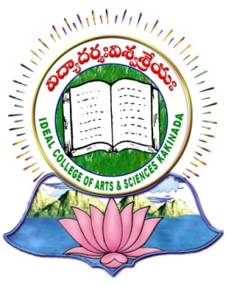 | IDEAL COLLEGE OF ARTS AND SCIENCES (A)
 | (A.P. Govt., Aided., Autonomous & NAAC B++)
 | VIDYUT NAGAR
KAKINADA
East Godavari Dist
Andhra Pradesh

Department of MBA PROGRAMME

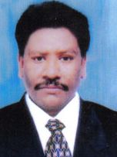

PROFILE

- Name : S.SAI SIVA RAMA KRISHNA
- Designation and Place of work : DIRECTOR MBA Programme
Ideal College of Arts and Sciences
Kakinada-533004
A.P., INDIA.
- Date of Birth : 16-06-1969
- Nationality : Indian
- Mobile no : 9848146276
- E-mail : krishnasurla@yahoo.com
- Address for Correspondence :
DIRECTOR M.B.A. PROGRAMME
Ideal College of Arts & Sciences,
Kakinada – 533 003, A.P., India.

- Details of Educational Qualifications:
Sl. No. | Course | University | Year | Specialization
1. | MBA | SHIVAJI UNIVERSITY KOLHAPUR | 1995 | MARKETING & PERSONNEL MANAGEMET
2 | B.L | ANDHRA UNVIERSITY | 1998

- Experience:

Sl. No | Designation | College | Date of Joining | Experience
1 | LECURER  HOD | IDEAL COLLEGE OF ARTS AND SCIENCE KAKINAD | 14-11-1995  01-05-1998 | 2.5 Years  12 Years
2. | DIRECTOR | IDEAL COLLEGE OF ARTS AND SCIENCE KAKINADA | 17-02-2010 | 7.5 years

- Regional/ State/National level Conferences/Workshops/Seminars

  - Attended NATIONAL WORKSHOP ON RESEARCH METHODOLOGY AND REPORT WRITING – COMMERCE, MANAGEMENT AND SOCIAL SCIENCES” on 29th – 30th January 2016, organized by Department of Management Studies, Adikavi Nannaya University, Rajahmundry.
  - Attended and presented paper at UGC National Seminar on” INSTITUTIONAL QUALITY MAINTANANCE AND IMPROVEMENT “, conducted on 21st and 22nd January 2017.
  - Organised two day workshop as coordinator in Stock Brocking and Mutual Funds on 7th and 8th February, 2013.

- Administrative Experience: 20 YEARS

- Training Programs/ Courses attended:
Attended National Seminar on Institutional Quality maintenance and improvement on 21st & 22nd January, 2017 at Ideal College of Arts & Sciences.

