IDEAL COLLEGE OF ARTS & SCIENCE

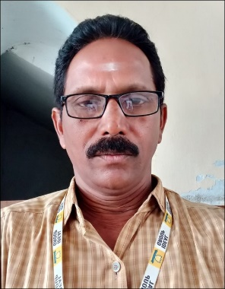

FACULTY PROFILE

Name of the Faculty: B.S.R. Krishna

**Academic qualification: M.A., (**Telugu language and Literature from Andhra University)

**B.L.,** (Andhra University)

Nationality: Indian

Date of birth: 01/08/1967

Designation and Place of work: Asst. Professor

Ideal College of Arts and Sciences (Autonomous) Kakinada

Experience:

18 years

Address for Communication: B.S.R. Krishna, #5-12, Nemam, Kakinada-5, A.P. 533005

Mobile: 9440 47 1746

E-mail: [bsrk.008@gmail.com](mailto:bsrk.008@gmail.com)