IDEAL COLLEGE OF ARTS & SCIENCE

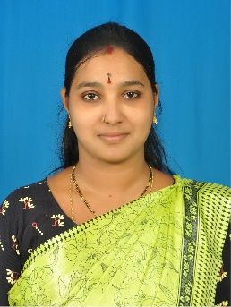FACULTY

Name of the Faculty: G. Sai Lakshmi

**Academic qualification: M.A., (**Telugu language and Literature from Andhra University)

D.Ed.,

Nationality: Indian

Date of birth: 20/09/1990

Designation and Place of work: Asst. Professor

Ideal College of Arts and Sciences (Autonomous) Kakinada

Experience:

08 years

Address for Communication: G. Sai Lakshmi, Indrapalem Kakinada-5, A.P. 533 005

Mobile: 8143150469

E-mail: [luckygollapudi1990@gmail.com](mailto:luckygollapudi1990@gmail.com)